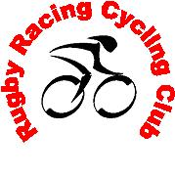Rugby Racing & Cycling Club
80th Anniversary & Awards Evening
Friday 23rd January 2009 – 7.30pm at Barby Sporting Club

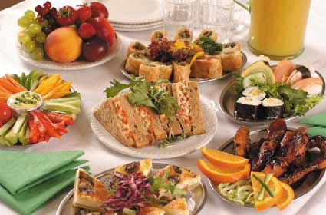

Please come and join us at the RRCC Annual Awards Evening and to celebrate the club’s 80th Anniversary.

Hot and cold buffet plus a selection of sweets will be available on the night. Tickets are just £15 each.
Sample menu: Carved meats (2) Ham/Beef/Turkey, Various Quiche Selection & Sausage Rolls, Potato Salad & Coleslaw, Prawns and Marie Rose Sauce, Scotch Eggs & Pork Pies, Rice Salad, Chicken Breast Bites, Southern fried chicken strips, Smoked Salmon with fresh salmon fillet, Breaded Brie Wedges & Spicy Potato wedges, Seasonal Salad Selection, Cheddar and Stilton Cheese with Biscuit Selection.

Sweets: Profiteroles and Chocolate Sauce, Wild Berry and Tropical Fruit Salad, Cheesecake Selection

Please confirm your attendance by 14th December using the slip provided.
- - - - - - - - - - - - - - - - - - - - - - - - - - - - - - -- - - - - - - - - - - - - - - -- - - - - - - - - - - - - - - -- - - - - - - - - - - - - - - - - - - - - - - - - - - - - - - - - - - - - -

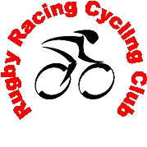

Rugby Racing Cycling Club

Annual Awards Evening & 80
th

Anniversary

Name:
_________________________________

Guest Name:
___________________________

Please reserve
_____________

tickets for the Awards Evening

I enclose £
___________
Payment in Full (
£
15 per head)

OR
deposit (£5 per hea
d required
to reserve tickets)

Please return to Sam Heaton, 6 Barley Close, Daventry, NN11 0FW (Tel 01327 311448)

